REGRESSION ANALYSIS
Polynomial regression
Polynomial regression, like linear regression, uses the relationship between the variables x and y to find the best way to draw a line through the data points.
# Showing actual data points
import matplotlib.pyplot as plt
import numpy as np
from scipy import stats

x=[4,5,6,5,44,58,65]
y=[15,85,45,46,12,95,23]
plt.scatter(x,y)
plt.show()

# polynomial regression
x = [1,2,3,5,6]
y = [100,90,80,60,60]
mymodel=np.poly1d(np.polyfit(x,y,3))
myline=np.linspace(1,15,100)
plt.scatter(x,y)
plt.plot(myline,mymodel(myline))

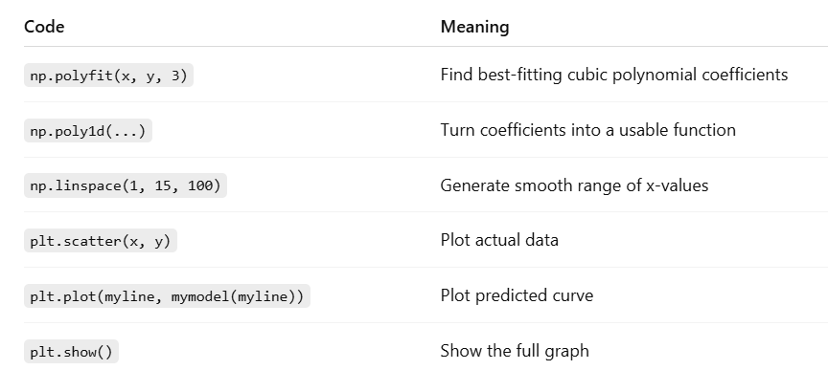

# R² Score
It is important to know how well the relationship between the values of the x- and y-axis is, if there are no relationship the polynomial regression can not be used to predict anything.
The r-squared value ranges from 0 to 1, where 0 means no relationship, and 1 means 100% related.

from sklearn.metrics import r2_score
print(r2_score(y,mymodel(x)))

good r² score: 0.9432150416451026

# future prediction
marks=mymodel(4)
print(marks)

# bad fit data for polynomial regression (low r² score)
x = [89,43,36,36,95,10,66,34,38,20,26,29,48,64,6,5,36,66,72,40]
y = [21,46,3,35,67,95,53,72,58,10,26,34,90,33,38,20,56,2,47,15]

mymodel=np.poly1d(np.polyfit(x,y,3))
myline = np.linspace(min(x), max(x), 100)
plt.scatter(x,y)
plt.plot(myline,mymodel(myline))

print(r2_score(y,mymodel(x)))

bad r² score: 0.009952707566680652

